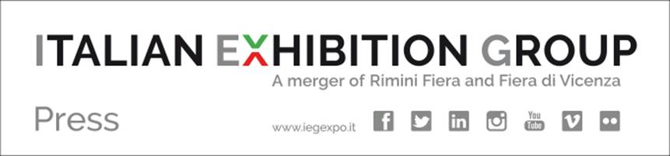

Press Release

ITALIAN EXHIBITION GROUP - EXCELLENT BALANCE PERFORMANCE FOR THE FIRST HALF OF 2017. REVENUE, EBITDA AND NET RESULT UP

- 71.3 million euros total consolidated revenue (60.3 as at 30th June 2016)
- Consolidated EBITDA¹ 16.6 million euros (11.7 as at 30th June 2016)
- 8 million euros net result (+224% compared to 30th June 2016)

Rimini, 3rd October 2017 – Today, the Board of Directors of ITALIAN EXHIBITION GROUP S.p.A. approved the half-yearly financial report as at 30th June 2017. The comparison with the data as at 30th June 2016 regards the pro-forma¹ consolidated financial statement, i.e. as if the foundation of IEG was dated 1st January 2016 and the profit and loss account expressed the entire activity of the merged companies during the second half of 2016.

The main consolidated results for the first half of 2017

The Production Value of the first half of 2017 was 71.3 million euros, an increase of 18.3% on the pro-forma first half of 2016 (60.3 million), thanks also to a more favourable expo calendar, enriched, among other things, by the Arezzo gold exhibitions.
There was an even clearer growth in operating profitability, with an EBITDA² for the first half of 2017 of 16.6 million euros, 42.6% up on the 11.7 million as at 30th June 2016.
The net consolidated result for the first half of 2017 was 8 million euros, which was more than triple the 2.5 million of the 2016 pro-forma first half report.

As at 30th June 2017, the Net Financial Position has a negative value of approximately 51.2 million euros, confirming an absolutely sustainable profitability:debt burden ratio. In fact, the growth of the debt burden compared to pro-forma 30/6/2016 (+5.4 million), is modest when taking into consideration the 10 million euros distributed in dividends, investments for the extension of Rimini expo centre and purchases made over the last 12 months.

Lorenzo Cagnoni, president of Italian Exhibition Group SpA, comments, “These are really important figures, which position IEG in second place among Italy’s trade fair centres for turnover and first as far as exhibitions organized directly and business profitability are concerned. These figures confirm the solidity of our business plan and further strengthen our on-going domestic and international strategies and the appreciation shown by the market. IEG management is therefore confident that it will achieve the ambitious results forecast by the 2017 budget 2017, in line with the excellent results in 2016, a year that had a more favourable expo calendar in the second half.”

ITALIAN EXHIBITION GROUP SPA: FOCUS ON
Italian Exhibition Group SpA, the company founded with the merger between Rimini Fiera e Fiera di Vicenza is helmed by president Lorenzo Cagnoni, executive vice president Matteo Marzotto and general manager Corrado Facco. IEG is Italy’s second player for turnover, with 59 expos (regarding the Food & Beverage, Green, Technology, Entertainment, Tourism v, Transport, Wellness, Jewellery e Fashion, Lifestyle & Innovation trades) and has a total of 216 events and conferences.
The company's priority asset is favouring the internationalization of these sectors, which represent everything Beautiful and Well-made worldwide, starting off with a solid joint venture in the United Arab Emirates and presences in the USA, China, India and South America. IEG is also Italy’s leader in the conference and congress sector. In 2016, IEG hosted a total of 14,593 exhibitors and almost 2.5 million visitors in its expo and conference facilities in Rimini and Vicenza.
Italian Exhibition Group’s leading expos undergo certification by the ISFCERT institute, recognized by ACCREDIA, according to ISO 25639:2008 international standard (Exhibition Terminology and Measurement).

ITALIAN EXHIBITION GROUP SPA PRESS CONTACTS:
Elisabetta Vitali - head of national media & corporate communication mediarimini@iegexpo.it
Patrizia Rovaris - head of international media & corporate communication mediavicenza@iegexpo.it
Marco Forcellini - press office manager Rimini office marco.forcellini@iegexpo.it

¹ The pro-forma financial statement is intended as being the financial statement of Italian Exhibition Group SpA is if the merger between Fiera di Rimini and Fiera di Vicenza had effect from 1st January 2016 and therefore as if the financial statement showed in the profit and loss account all the activity carried out by the two companies during 2016. Due to the technical aspects of the merger (contribution of Fiera di Vicenza to Rimini Fiera), the effective profit and loss account of the company shows the whole of 2016 of Rimini Fiera and the months of November and December of Fiera di Vicenza,

²The EBITDA is represented by the operating results (earnings) before interests, taxes, depreciation and amortization. EBITDA is an indicator defined and used by the Group to monitor and assess the Group’s operating performance, but is not defined in this context by the IFRS; so it must not be considered as an alternative indicator for the assessment of the performance of the Groups’ operating result. The company considers the EBITDA to be an important parameter for assessment of the Group’s performance, as it enables to analyze its marginality, eliminating the effects due to non-recurrent economic elements. Since the EBITDA is not an indicator whose determination is regulated by the reference accounting standards for drawing up the Group’s consolidated financial statement, the criterion applied for the calculation of the EBITDA might not be homogeneous with that adopted by other groups, so might therefore not be comparable.

